**Botnet**

Additional Botnet capabilities

We added a number of functions to flock in to add more control to the botnet. These functions are implemented in both birdire.py and in ircbot.py. They provide functionality for retweeting, deleting one or more tweets, deleting all tweets older than a certain time, and a reo post attack. The attack begins by randomly selecting a bot. Then it grabs the 200 tweets and checks if they have been tweeted by the bot and if they contain a URL. The tweets are chosen from a list of University of Michigan accounts that I created on JoseClark92's twitter. If it hasn't been tweeted and it has a URL, then the URL is replaced with our malicious link, and the text of the tweet is tweeted by our bot. If it doesn't have a link, the tweet is simply retweeted. The repost attack reposts a tweet with our link replaced. The attack was intended to run roughly every 30 minutes plus or minus a random time no longer than 10 minutes.

Difficulties with the Botnet

However, the app's write permissions were removed after doing some manual testing. We to deleted our app and created a new one. The same bots were registered to the app, SocialSynergy. It may not have been a good idea to add them to both apps, but we didn't want to go through the trouble of creating more bots. SocialSynergy also had its write permissions removed after manual testing. This time we contacted Twitter about restoring permissions, claiming to be a startup that was testing an app that would combine all of your social media accounts in one application. They shortly suspended the app. We never were able to properly run the scheduling because our apps got suspended too quickly.

Speculation of Twitter App suspension

It is difficult to determine why our app was suspended. It may have been because we didn't have a website and the description of our startup was somewhat vague. Or it could be because all of the bots were posting at the same time. They might have also been checking if one user's tweets are almost identical to another's. One of our biggest problems was finding a good source of text to tweet. We didn't want to choose from a manually created list of tweets because that seemed to defeat the purpose of having an automated botnet. The reason for suspension might have been that we were reusing other people's tweets with only the link changed. We deleted all tweets from the repost attack that are older than an hour to remove the evidence, but Twitter still has a record of everything we tweeted. To dismantle the bot army, we would have to deactivate each account manually. Ultimately, it is extremely difficult to pass off a robot as a human. Our extensions to flock give us the ability to carry out a wider range of attacks, but we were unable to come up with a bot based attack that got past Twitter's detection system. We decided to concentrate our efforts on our primary attack because it was much more effective at getting clicks.

Several fake Twitter profiles we were able to use in the botnet are included in /Profile Screenshots/.

**Open Groups within University of Michigan**

Primary Method

This attack did not make use of any bots, but proved to be highly affective. This attack depended on the use of our website, UMichJobs.com that loads a hidden iframe with a bit.ly shortened link of our attack link. The aim was to target students who are looking for career opportunities (internships, jobs). Since the beginning of our attack, we changed the featured companies on the web page as to attract a wider audience of people. The website was functional with a signup process involving sending an email with a person’s name, email and short message describing what they are looking for in an internship opportunity:

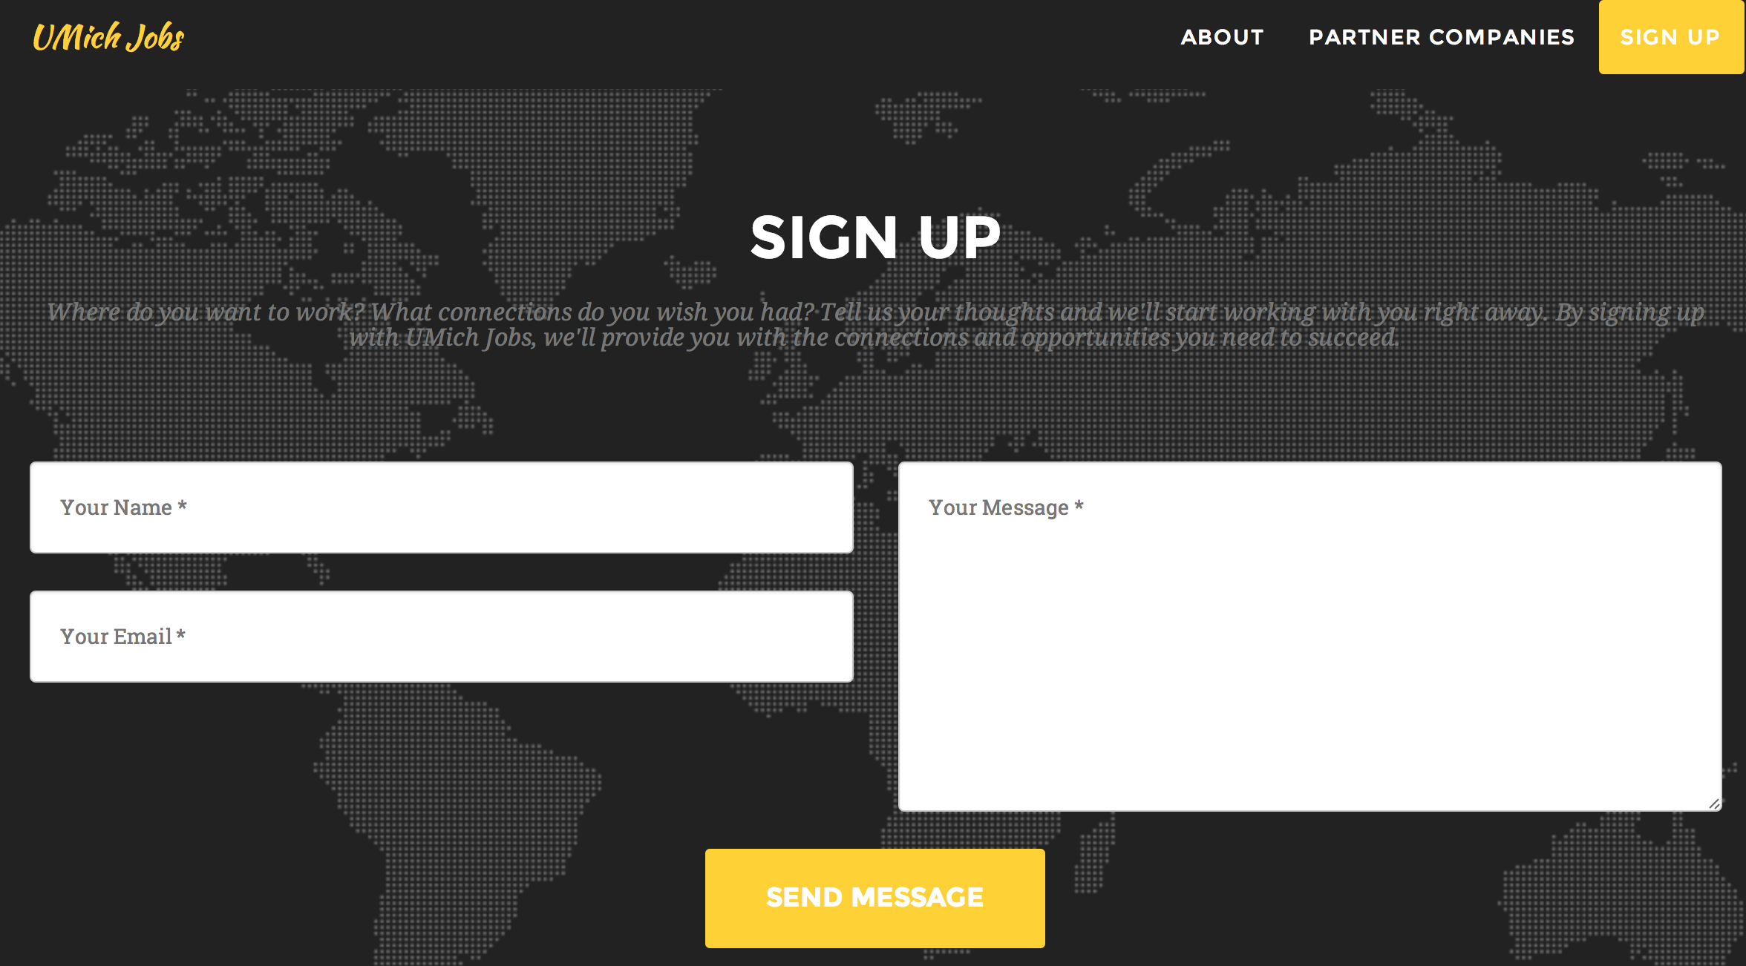

I got in contact with two students currently attending the University of Michigan. One was aware of the true purpose of spreading the link, and the other was unaware by means of social engineering. Both effectively helped me spread the link to Facebook groups at University of Michigan.

Social Engineering

For one student that I contacted at University of Michigan, who I knew before this project, I was able to convince this person that I was part of a social networking course and that a project I was working on was to spread a link as quickly as possible to get as many people as possible to click on it. The student was eager to help me out and posted the link to several pages. Examples are shown here: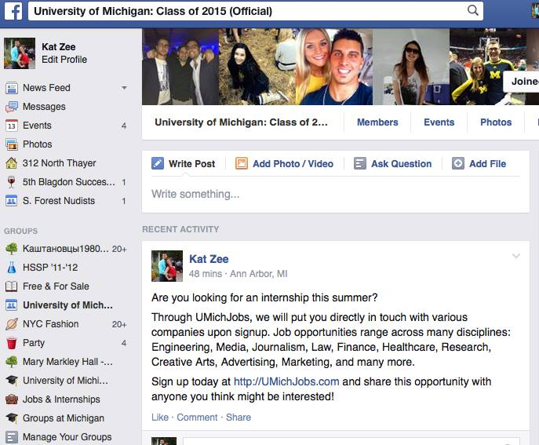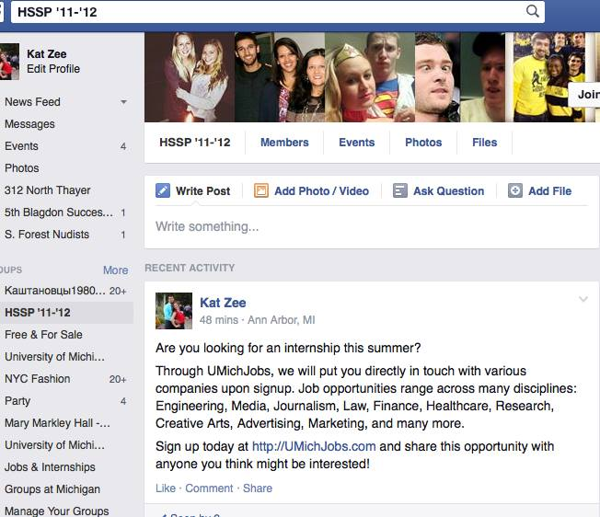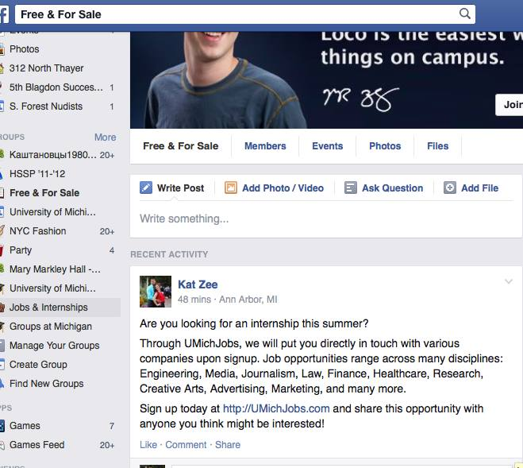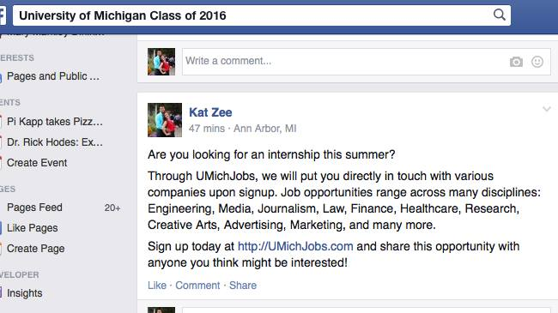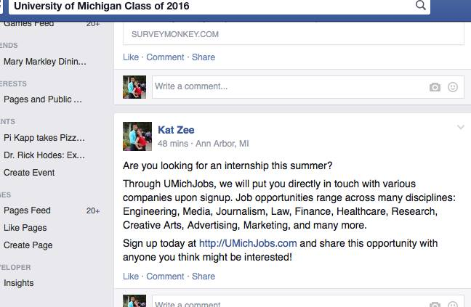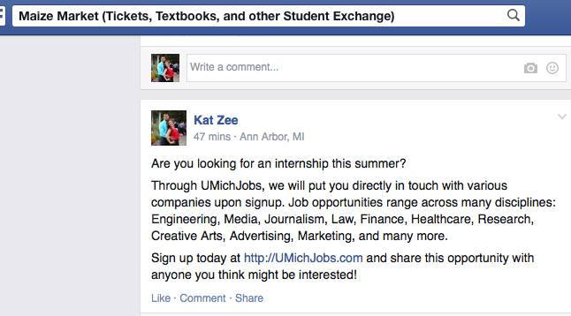

Insider Attack

I was able to get in contact with a UMich student who provided me an email alias using in the umich.edu domain. This allowed me to gain access to groups exclusively open to UMich students. Because of time restrictions, I was not able to create a fake profile to post from. However, I found that using my regular Facebook account was actually quite effective. I had posted in 48 groups ranging from, but not limited to, specific interests (clubs, Greek life) to student exchanges (textbooks, free/for sale) to degree-related groups (Engineering, Journalism, Computer Science). Example snapshots are included below:

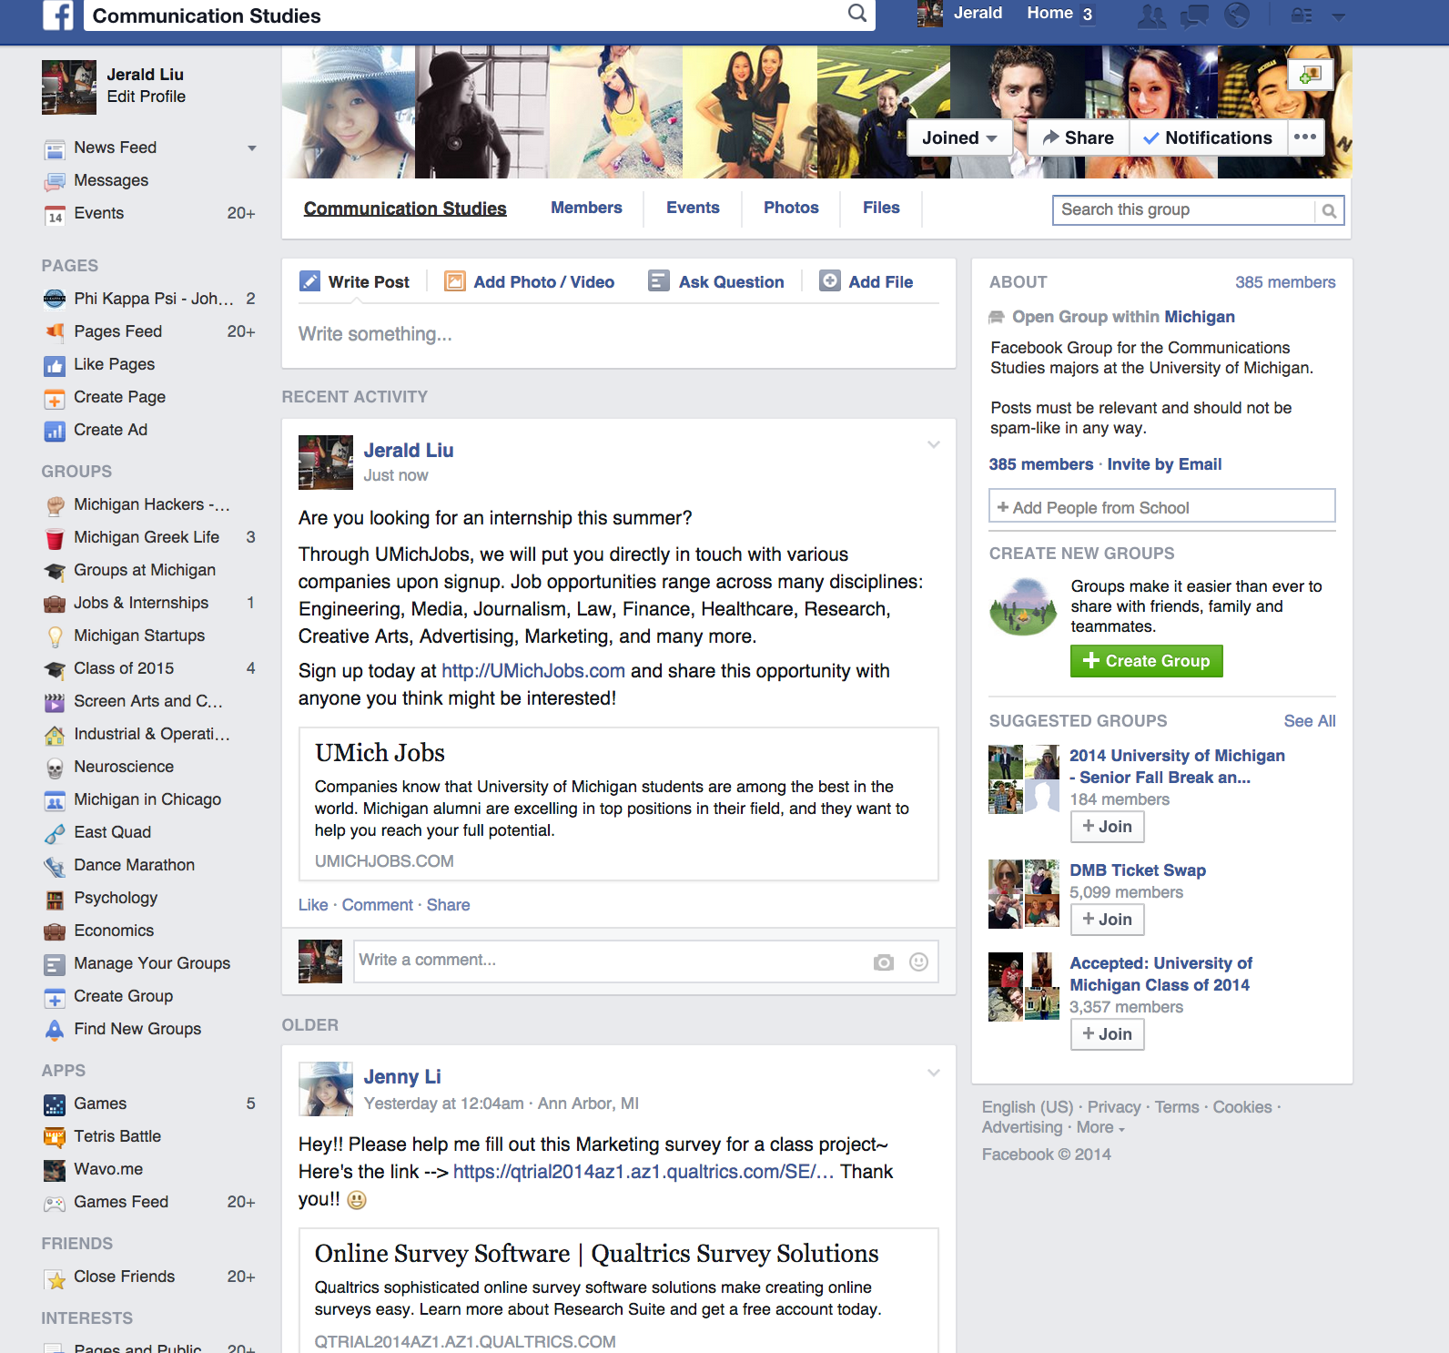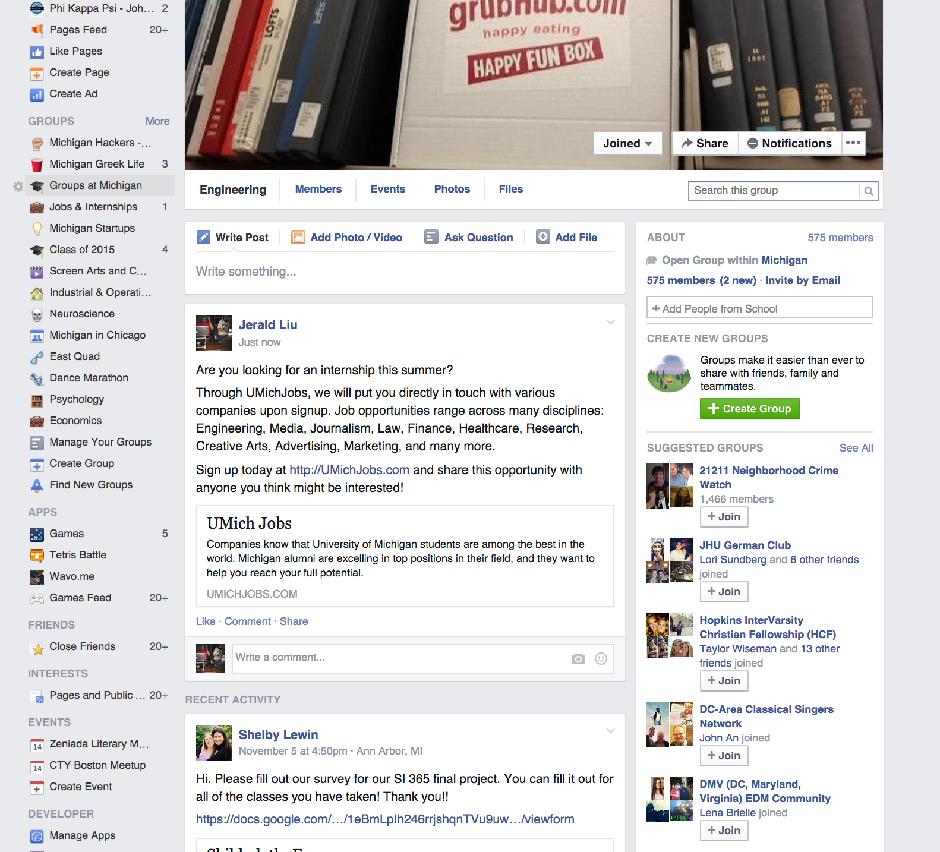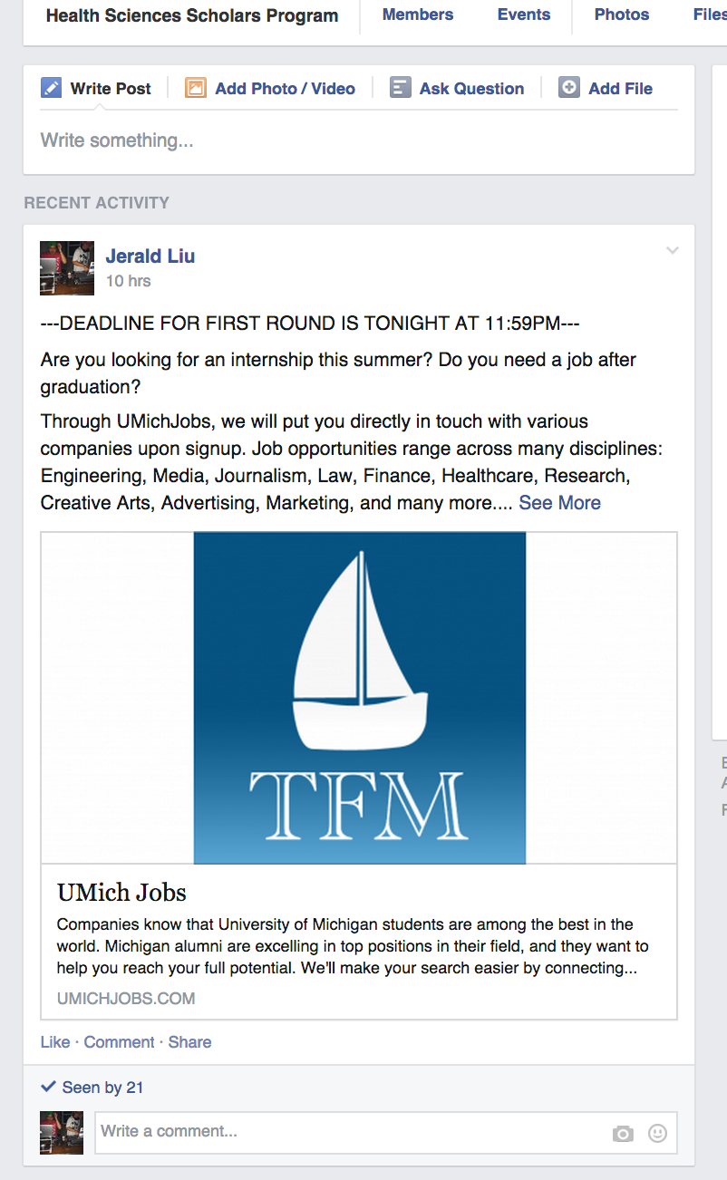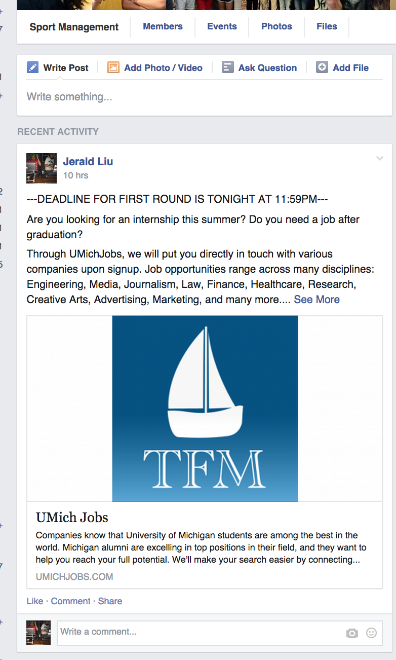

Analysis

As of Monday, November 17th at 11:32am, we were able to attract 921 clicks (possibly including 20 or so clicks by us). In the bit.ly chart below, it is clear when the attack began, November 13th. That night I had contacted the person who posted the link with her own profile. The next morning on November 14th was when I had gained access to the UMich pages on FB. I reposted to those groups on November 16th, explaining the spike in click activity.

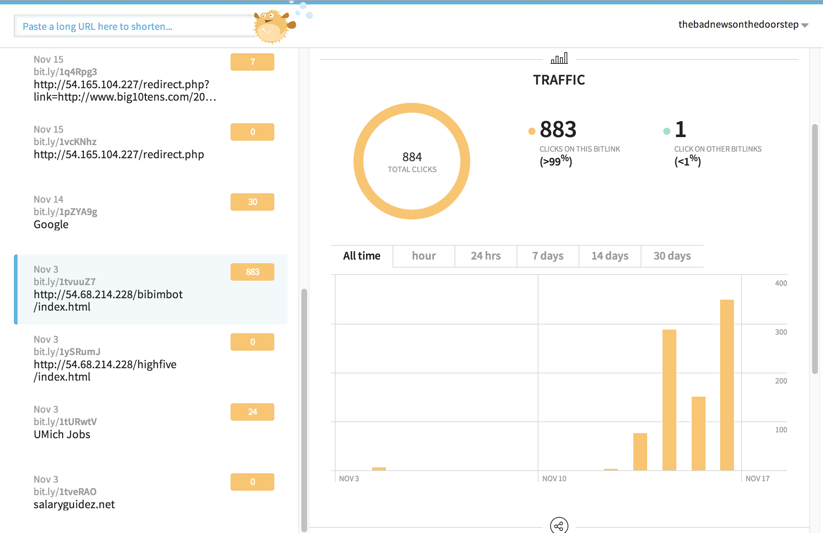

We were able to acquire 113 contacts via email through the website:

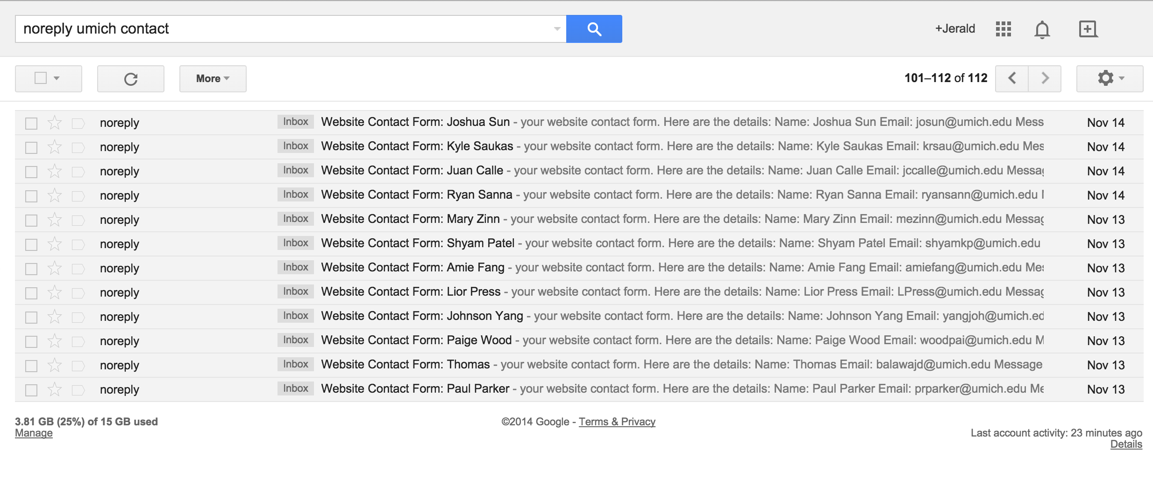

While most of the emails regarded Engineering and Science related internships, there was still a wide breadth of interests, such as social media, advertising, marketing, PR, HR, sports management, communications, and many more: 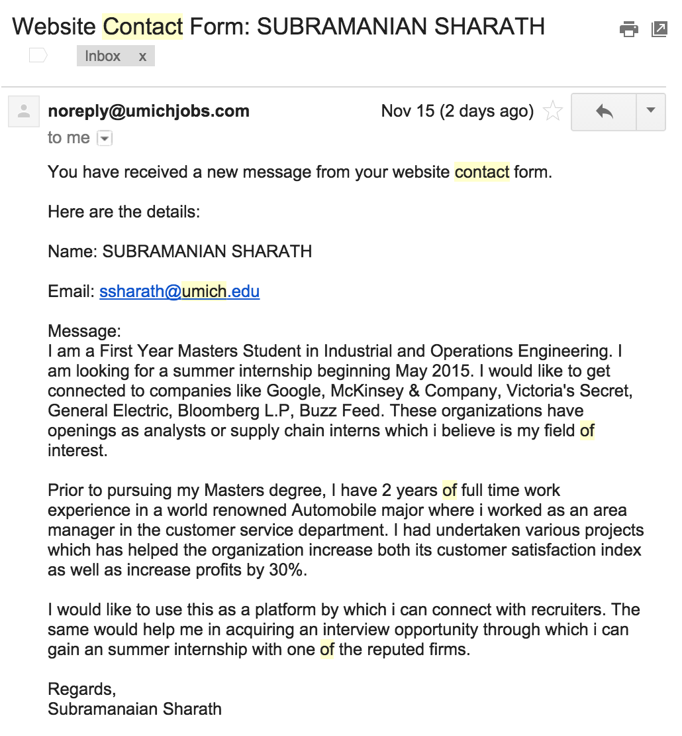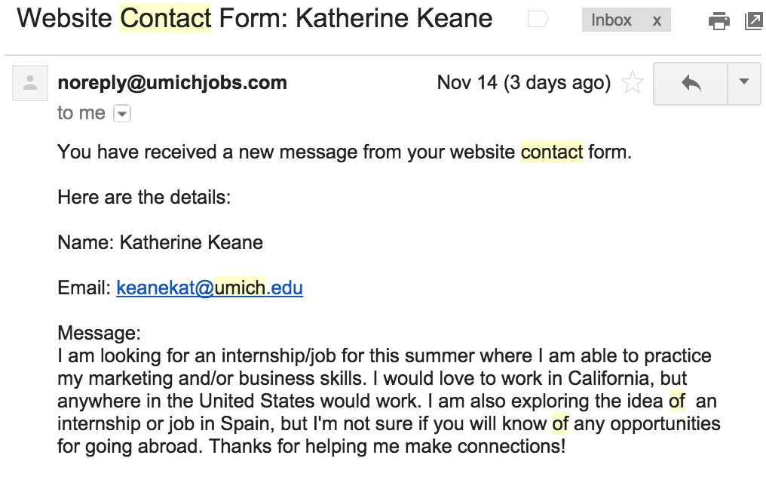

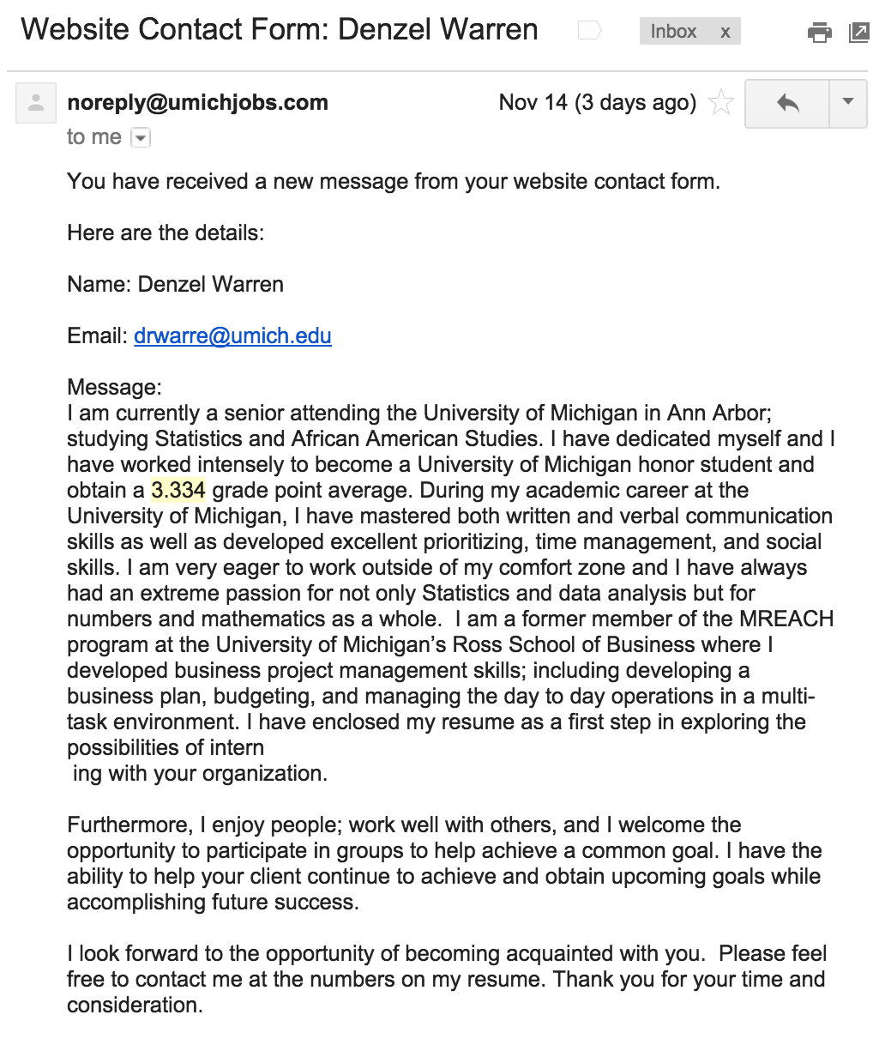

Some even had blank messages: 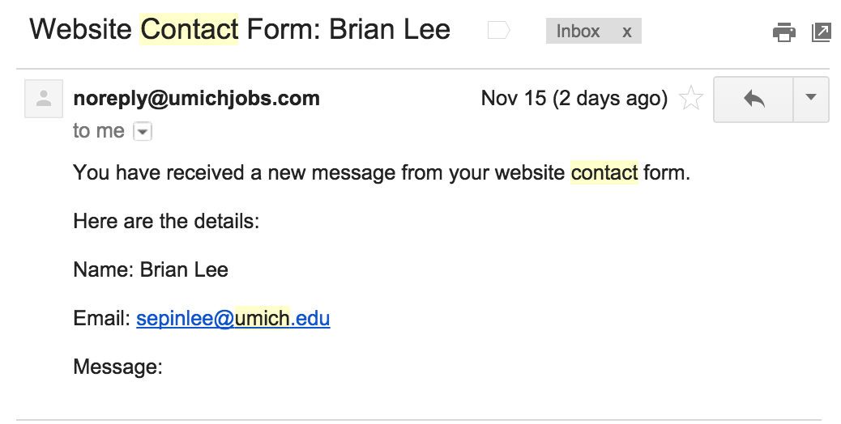

There was a 113/921=**12.27%** turnover rate from clicking then signing up through our website.

We analyzed the data that people emailed to UMich Jobs to get an idea of the demographics that the attack was successful for. All of the emails sent to us were downloaded into the file attack_emails.mbox. The script email_analysis.py loads in this file and then counts the number of appearances of each word. Our preliminary analysis showed that, there were 8 freshmen, 4 sophomores, 6 juniors, 13 seniors, and 5 alumni (not all emails contained information regarding year). It makes sense that seniors are most common since they are currently looking for a job. However, it would also be a good idea to target underclassmen since they are more likely to live on campus.

Implications/Further Work

We’ve acquired a significant amount of data from presumably real University of Michigan students including their names, umich.edu emails, and interests/disciplines. A few things can arise from this aggregation of information:

1. We can email the students back and further socially engineer by making it seem like someone working for UMichJobs is actually listening to them; and
2. We can use this information to generate fake profiles and leverage an entire botnet based on these people.
3. We can also use analysis of demographics to then have targeted ads to extend our attack.

**Babes of UMich Twitter Account**

Primary Method

We made a Twitter account (https://twitter.com/GirlsOfUMich) centered on posting links to galleries (big10tens.com/category/girls/michigan/) of attractive young females (SFW) at University of Michigan. There is a python script called michgirlsscraper.py in BabesOfUMichScraper/ that takes in a URL as an argument and looks for links corresponding to different galleries.

We then made a page called redirect.php (first had php in it, then had to remove it, but we didn’t change the filename). This page would load the same hidden iframe as in our UMichJobs.com page, but then would redirect to a website when given a URL parameter containing the redirect link. This redirect link would be the link of a specific gallery. An example is http://54.165.104.227/redirect.php?link=http://www.big10tens.com/2013/08/26/back-by-popular-demand-jessica-ashley-from-michigan, where the IP address is the public facing IP for our AWS instance, and the link parameter contains a link to the gallery.

We would then shorten this link with bit.ly and would only then make a tweet through the Babes of UMich account.

Here is a screenshot of our Twitter profile:

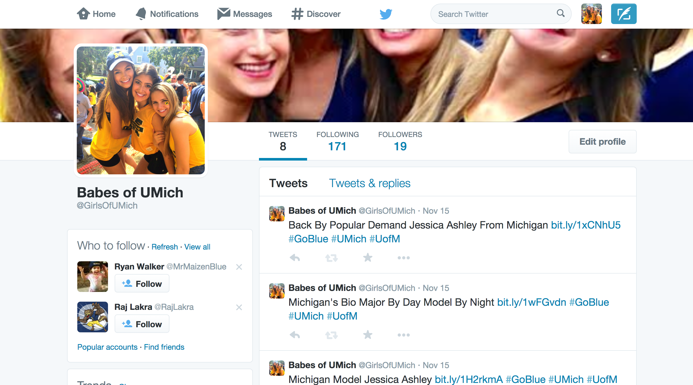

Analysis

According to our bit.ly account, there were absolutely no clicks on our links. This I believe is because our hastagged tweets did not actually make it our to people’s streams. After looking up the hashtags, it was apparent hastagging is more complicated than it seems. We speculate a hashtagged tweet actually making it to people’s news feed is a function of location, how long the profile has existed, followers of the profile and people following the profile.

Had our Twitter app not been suspended, perhaps more use could have been made of this profile. Unfortunately due to time constraints, we had no option but to fall back onto our primary attack which eventually involved no bots.

**Peripheral Attacks**

Piggybacking On Other Team’s Twitter Apps

When we were first setting up our botnets, Zack allowed people to send him their credentials so that he could set up the flock registration link for us. A spreadsheet containing these registration pages was then emailed to the entire class. Although we had already set up our botnet, we realized that it was possible for us to register one of our bots to another team’s botnet. Many of the links did not work, but we were able to successfully register the bot @PatriciaDobis to two different botnets. We hoped that these teams would tweet on this bot and then we would be able to get more information on their attack strategy. Although the account remains registered to both apps, they never used it to tweet from our bot. We do not know if this was because they realized that this was not one of their bots or if they ended up using a different app for the attack.

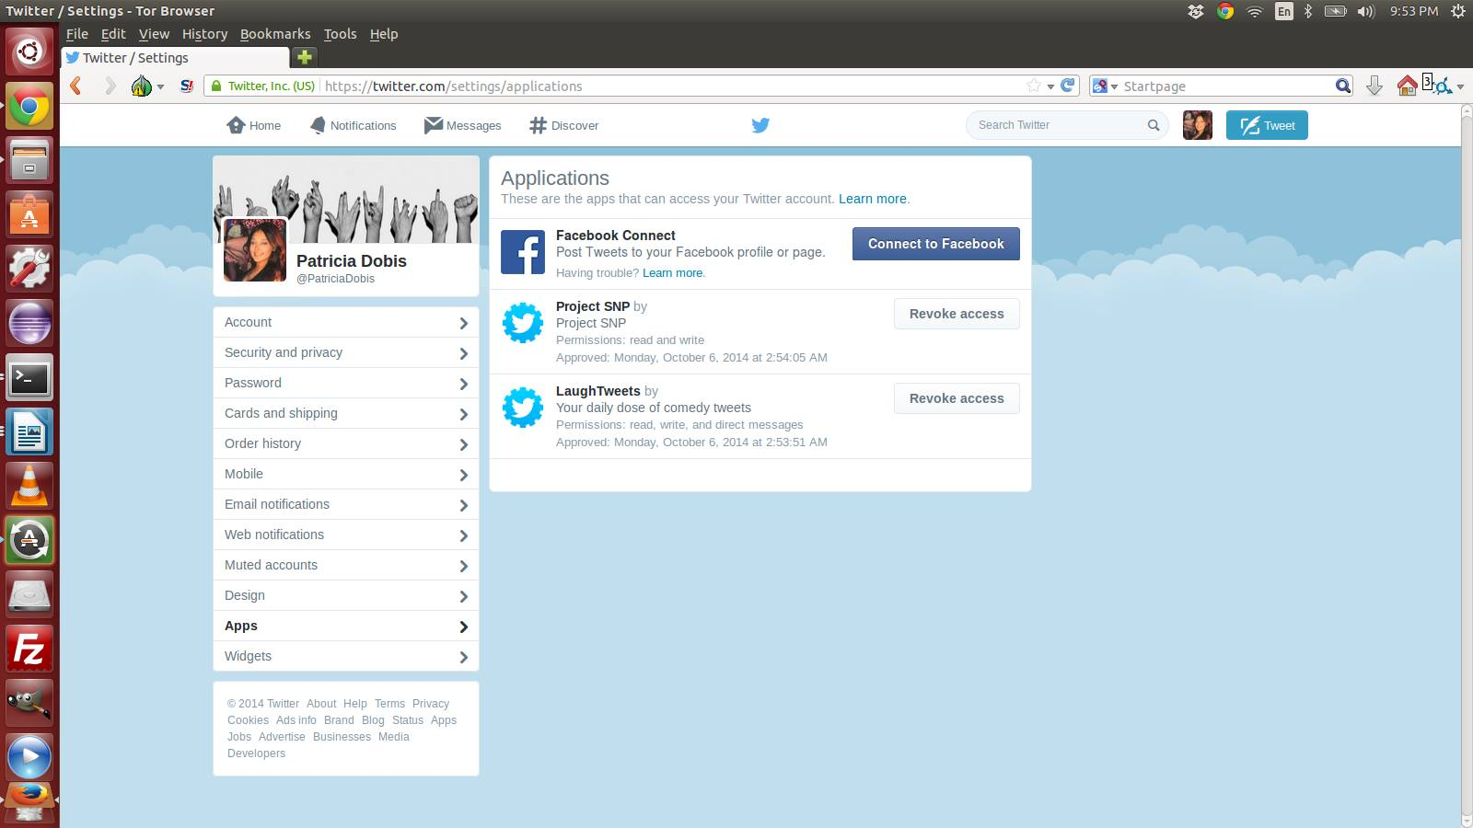

Unauthorized Account Access

During our defensive portion, we were able to login to other ZeroFox accounts. This attack was simple: The pattern for many, if not all, of the team’s accounts was the same (JHU[shortened-school-name]). And the password was always “changeme”. Because we had started early on using the ZeroFox platform, we saw the opportunity to access other people’s accounts and change their passwords before they could get to their accounts. This was made feasible for two reasons:

1. It was easy to guess big school’s names and thus the ZeroFox usernames
2. When we had guessed a wrong username, we were notified of this through the dashboard login. This is a flaw in the platform, as guessing usernames can be easy as performing a dictionary attack and is half the battle of guessing username/password combinations: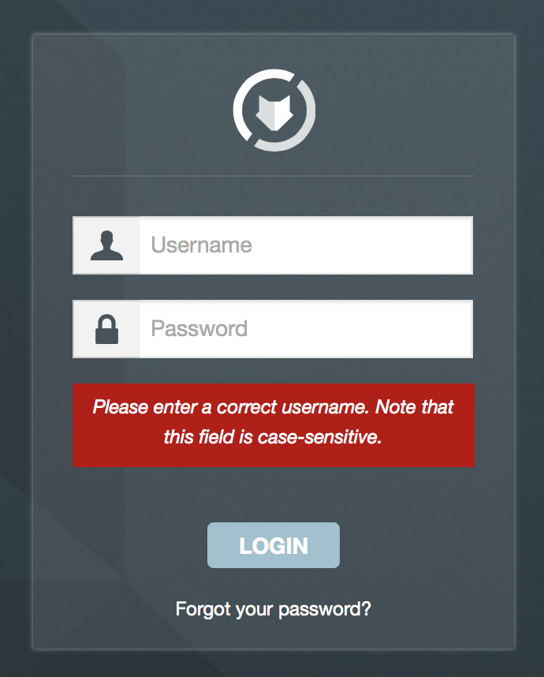

Accounts whose passwords we were able to change were: JHUCornell, JHUColumbia, JHUDuke, JHUPenn, JHUMich. It was interesting to see that some team’s had logged in (we could tell because we didn’t have to click ‘Agree’ to the terms of service) but had not immediately changed their passwords.

Account Lockout

During the offensive portion, we found that on the alert page, the HTML (alerts.html in our submission) had hidden an enormous JSON object containing all parties using the platform, including their names, which in the case of this project, helped us further find more team’s username. This made lockout of many teams’ accounts easy. We had simply typed in incorrect passwords for every valid username we could extract from the HTML. Specifically, we had at one time or multiple times locked out: JHUDrex, JHUVTech, JHUCuse, JHUPenn, JHUMiami, JHUUVA, JHUDuke, JHUGTech, JHUMich, JHUUNC. A couple we were not able to lockout due to restrictions made in an email from Zack.

Overview of ZeroFox Platform vulnerabilities/Recommendations

|  |  |
| --- | --- |
| Vulnerability | Recommendation |
| Dashboard Login gives too specific feedback on username-password combinations (i.e., tells when username is incorrect or not). This is not good, because an attacker can figure out valid usernames more quickly given feedback from the login system. Also, I was able to perform our pseudo-DOS attack from an unproxied IP address. | Only one error message should occur when username or password is incorrect: “Invalid username/password combination”. Also, to prevent brute force attacks, there should be a mechanism to detect excessive failed login attempts from a specific IP address. |
| Hidden JSON object in HTML of alerts page. While it is understandable that loading account data into hidden HTML elements yields implications of better performance when performing some search operations in the alert page, it exposes exactly what other institutions are trying to protect. An attacker, if competing with anyone listed in the JSON object, could easily attack entities not listed under a specific defender’s monitored entities. For example, if I wanted to perform an attack on Netflix, I’d avoid any entity associated with the Netflix JSON object. Another example, relevant to this project, is to avoid attacking/posing as entities listed under the UMich portion of the JSON object. | Dynamically load data in the JSON object. Or, only load data associated with one’s own account, not other people’s accounts. I should not be able to detect what entities other people are protecting. I should also not be able to tell who has an account in the first place. Any information regarding anyone else but me is dangerous to them. |